Overview
The State of Ohio will launch its new application portal October 19, 2026. Applicants are encouraged to download resumes and other attachments from their current profile to carry over to the new system.
Log In 1
Work Preferences 2
Work Experience 4
Education & Certifications 5
Additional Attachments 5
Submission History 6

Log In
- Log in to the Ohio Careers profile by selecting the name hyperlinks in the upper right corner.
- Select Profile from the drop-down menu.
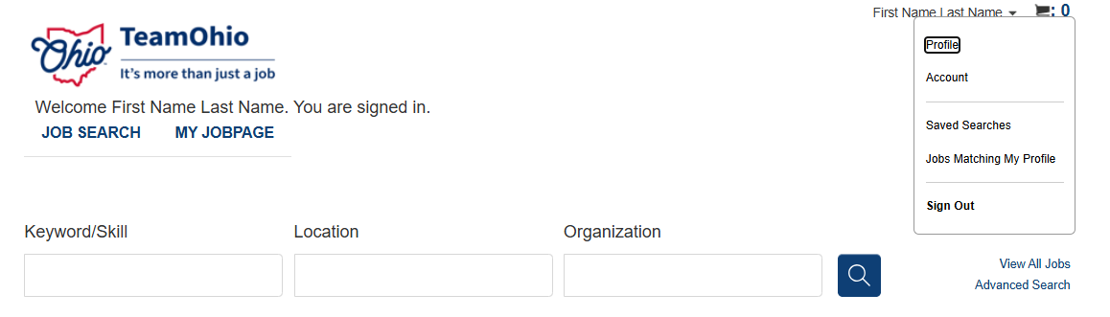
- Review each section of the profile by selecting the circles.
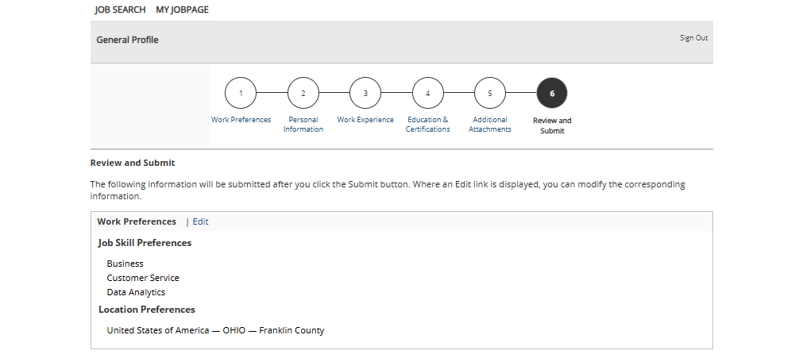

Work Preferences
- Review your selected job skills and print a PDF to ensure they are saved in an alternative location.
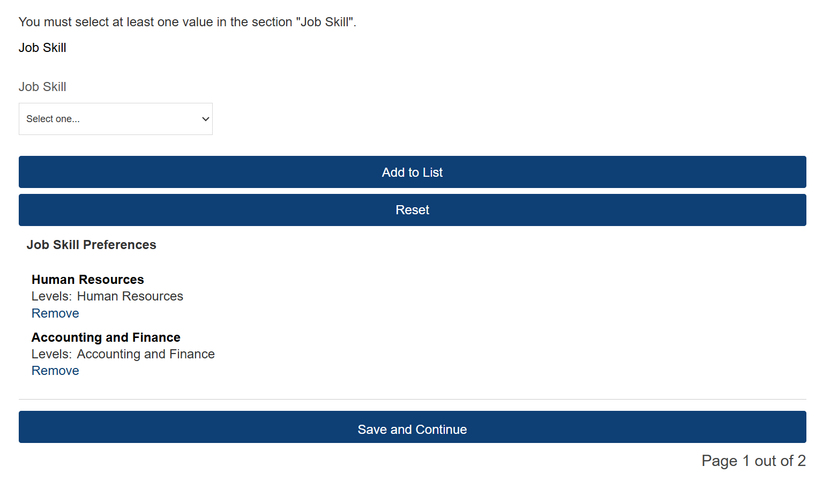

- Select Save and Continue.

- Review your selected location(s) and print a PDF to ensure they are saved in an alternative location.
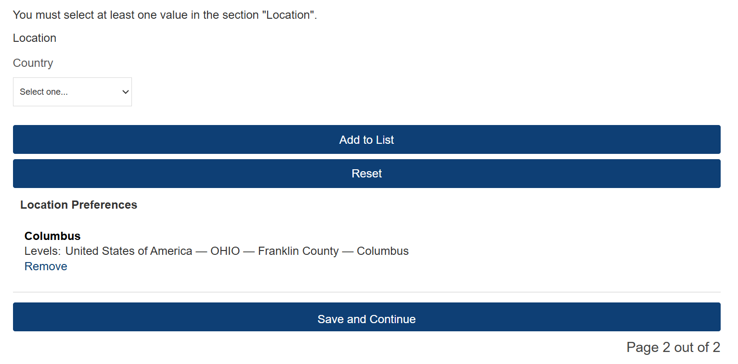

- Select Save and Continue.

Work Experience
- Print a PDF to ensure any work history is saved in an alternative location.
Note: Use the keyboard shortcut “Ctrl + P” to print to PDF.
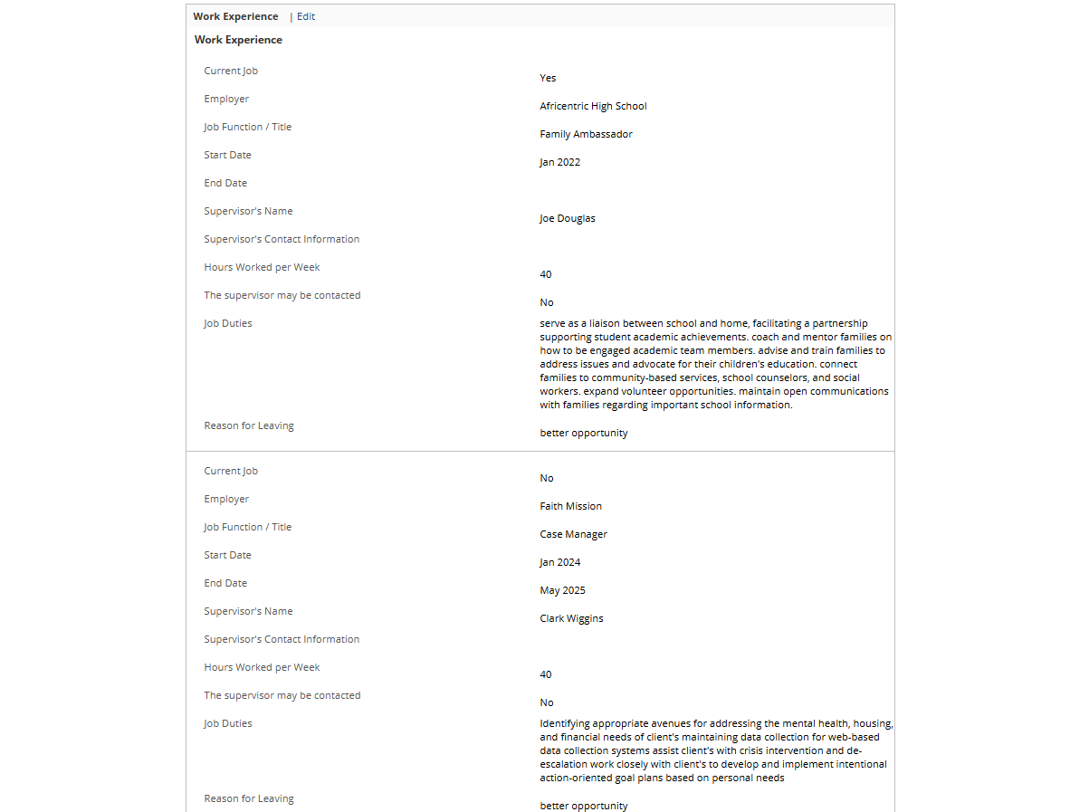

Education & Certifications
- Print a PDF to ensure any education history and certifications are saved in an alternative location on your device.
Note: Use the keyboard shortcut “Ctrl + P” to print to PDF.
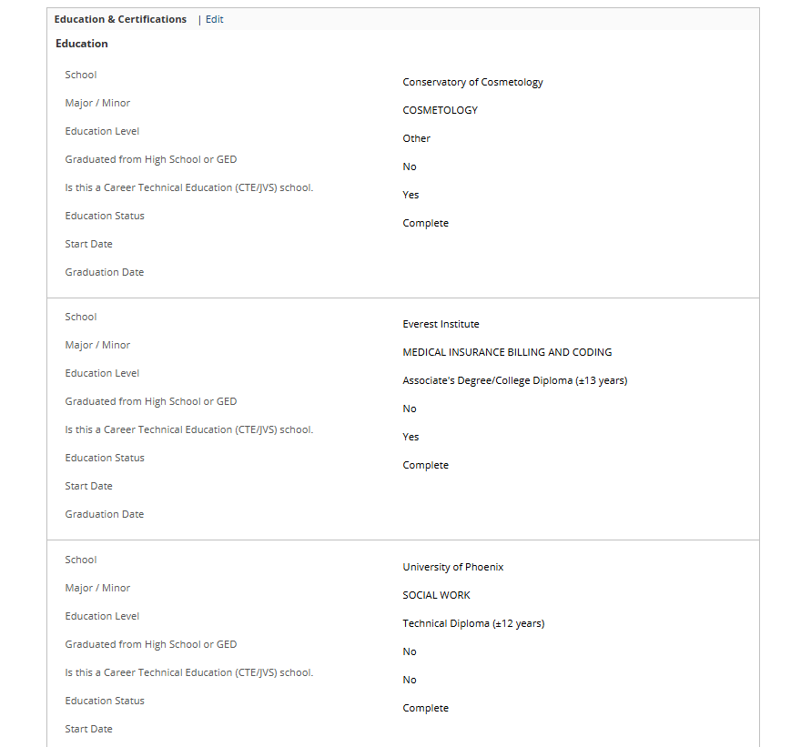

Additional Attachments
- Select the file name for each attachment to download a copy of the attachment.
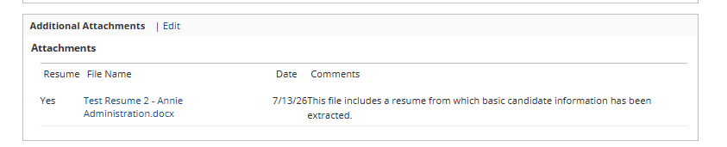

Submission History
Note: In preparation for the launch of the new application portal, there will be a blackout period from October 16, 2026, at 6 PM to October 19, 2026, at 8 AM. During this time, applicants will not be able to apply for State of Ohio positions.
Job applications submitted prior to October 16, 2026, will still be under consideration but will not be visible to applicants in the new system. As a result, applicants are encouraged to make a note of the job number and agency contact for any current submissions. The steps below detail where to locate this information:
- Navigate to My Jobpage to view current submissions.
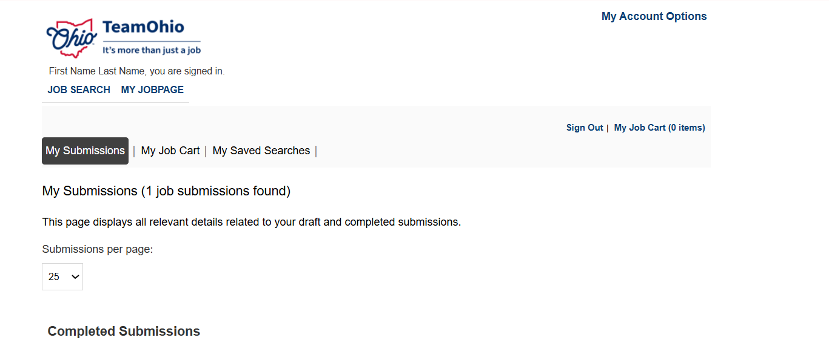

- The job number displays under the job title and location.
- Select the job title to locate agency contact information for a specific submission.
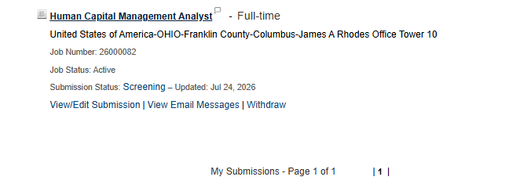
- The agency contact name and information displays at the top of the page, under the posting details.
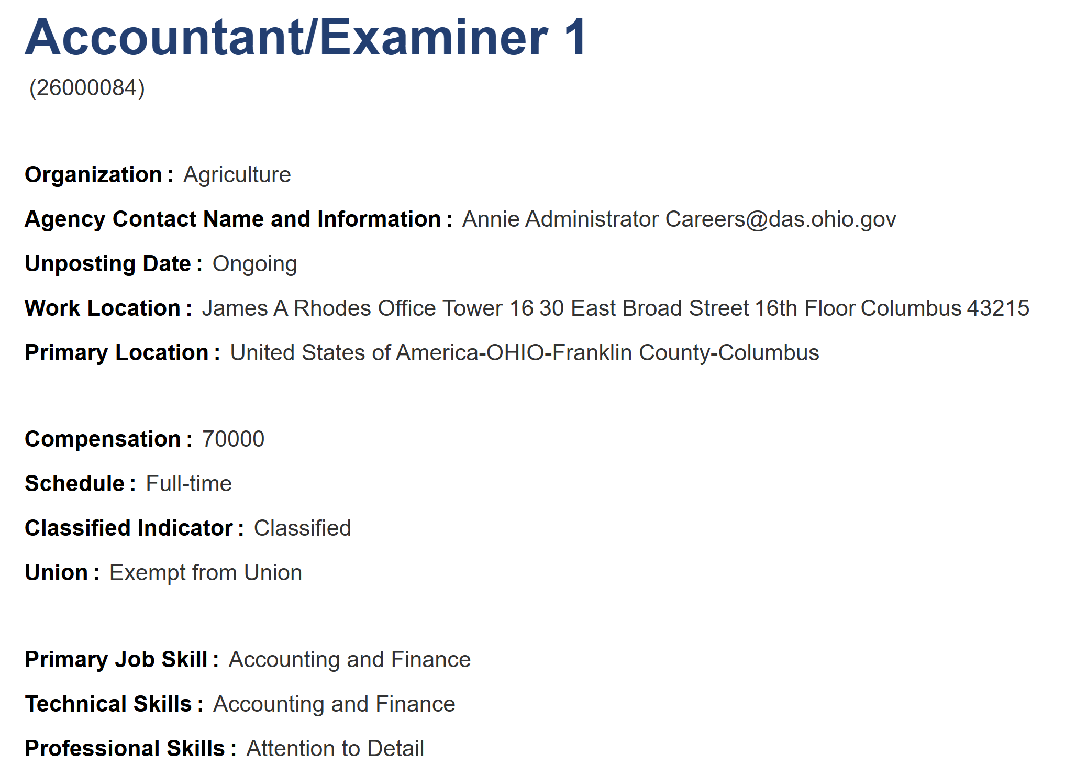
For additional questions, please email Careers@das.ohio.gov for assistance.

