Funding
Is there funding available to help complete the inventory? | Ohio EPA hosted a webinar that covers different grant or loan options to help with completing the inventory or replacement of lead service lines.
General
Who is required to complete a service line inventory? | All non-transient non-community (NTNC) and Community water systems are required to submit an initial inventory by October 16, 2024.
My system is a NTNC, what service lines must I include on my inventory? | The raw water line connecting your well to a building (without extensive distribution system) must be included on your inventory. If your NTNC only has one building, you will only need to complete one line on the inventory template. If your NTNC has two buildings, you will include the line from the well and the line connecting the two buildings. Interior plumbing of a building is not a service line.
My system is a Community, what service lines must I include on my inventory? | All service lines connecting the water main to a building, regardless of actual or intended use (potable and non-potable). This includes service lines owned entirely by the customer as well as both the system-owned and customer-owned portions where ownership is split. Vacant or abandoned building’s service lines must also be included as long as the service line is connected to the main and building.
Do we still need to do the inventory if we already completed a lead map? | The service line inventory is a new requirement that is different than the lead maps that were previously required. Information obtained to complete the lead map can be helpful in completing the service line inventory. All NTNC & Community public water systems must submit a service line inventory.
Do we need to do the inventory if I have no lead lines? | Yes, the inventory is required for all NTNC and Community systems to complete regardless of service line material.
What is a lead service line (LSL)? | An LSL is a portion of pipe that is made of lead, which connects the water main to the building inlet or a well to the building inlet for NTNC.  An LSL may be owned by the water system, owned by the property owner, or both. If the only lead piping serving the home is a lead gooseneck, pigtail, or connector it is not considered an LSL.
What is the difference between galvanized and galvanized requiring replacement (GRR)? | GRR is a galvanized service line that is or was at any time downstream of an LSL or is currently downstream of a lead status unknown (unknown) service line.  If the water system is unable to demonstrate that the galvanized service line was never downstream of a LSL, it must presume there was an upstream LSL. If the only lead piping serving the home was a lead gooseneck, pigtail, or connector it is not considered a GRR.
How do I know if the service line use is drinking water or non-drinking water? | Common service lines with non-potable applications include fire suppression or those designated for emergency use only. If these go into a building, they need to be included on the inventory. For service lines that don't go into a building and are used for a non-potable use (e.g. irrigation system) should not be included on the inventory.
How many unknowns are we allowed to have on our inventory? | There are no restrictions on how many unknown service lines can be included in the inventory. Keep in mind that there are additional notification requirements for sites with lead, GRR, AND unknown service lines.  The number of unknowns in the inventory should decrease as systems gather new information through normal operation and any proactive material identification activities. Currently in the proposed LCRI any system with unknowns on their inventory in 2027 will need to go back to 6-month monitoring for at least 2 monitoring periods.
Pre-Inventory Data Collection and Identification Methods
What date can we use to assume that service line is not lead? | Ohio adopted the lead service line ban on September 12th, 1988. Any service lines installed after this date can be assumed to be non-lead.
Do all lines need to be dug up and exposed to determine the material? | No, systems are not required to dig up all service lines to determine the material.  The minimum requirement is to review all available historic records including previous materials evaluation, construction/plumbing codes/records, water system records, and distribution system inspections and records.
What methods can be used for service line material identification? | Systems can use multiple types of identification methods in addition to the required records review (40 CFR 141.84(a)(3)). Some additional methods could include using the Ohio lead banned date of 1988, visual inspections, customer surveys, predictive modeling, water sampling (for lead identification only), etc. Please contact Ohio EPA if your system is requesting to use an identification method not listed here.
I am using statistical/predictive modeling for my service line inventory. Do I need to have my model approved by Ohio EPA? | No. Public water systems (PWS) are encouraged to follow guidance provided by US EPA for approaches to determine service line materials for the service line inventory due on October 16, 2024. PWSs are asked to provide Ohio EPA with the method used to determine service line materials in their service line inventory. In cases where a system is using predictive modeling as a method of identification of service line material, it's recommended to indicate that method on the inventory. The model does not need pre-approval by Ohio EPA.  Systems should be aware that the proposed Federal Lead and Copper Rule Improvements (LCRI) includes a requirement for systems to do a percentage of physical verification of non-lead service lines.
My system is a NTNC, what is the easiest way for me to determine my service line material? | All systems, including NTNC, are required to complete a records review (40 CFR 141.84 (a)(3)). If you are unable to determine your service line material with records, the next best way to identify your material is by visually inspecting the raw water line as it comes into the first building. Any connecting separate buildings should be included on the inventory and can be identified the same way. For help with identify your service line material, please refer to Appendix A.
Should all lines greater than 2” be characterized as Unknown Unlikely Lead and what is the ramification to doing so? | Ohio EPA and US EPA recognizes that the majority of lead lines have a diameter of 2” or less, however there are some rare lead lines reports at 3” in diameter. You can mark any lines >2” in diameter as “Non-lead – Other”. Validation will still be required for a percentage of the non-lead lines determined using identification methods other than from records, visual, or previously replaced lead or GRR lines. Validation requirements are currently proposed in LCRI.
How do we account for inactive or abandoned service lines on the inventory? | If a service line is connected to the water main and building it is required to be on the inventory even if it is shut off and the property is abandoned. If the service line is cut and physically disconnected from the main or the building, then it can be left off the inventory.  *See Appendix B for a diagram of this explanation. *
Are the service lines after a master meter required to be on the inventory? | When there is a master meter, at an exempt water system, any service lines that are on the customer side are not required to be on the service line inventory. It is recommended to include those lines when they material type is known or can be acquired. In a situation where a service line splits off to multiple customers that are individually billed then those are required to be on the inventory.
How to Fill out the Inventory Template
How do I find the latitude and longitude of service line location? | Google Maps or a similar application can give you the latitude and longitude. The exact latitude and longitude of the service line is not needed. Any point on the building or parcel is acceptable.
What do I do when there are multiple plumbing materials inside the home or building for the recommended column “AM” in the Inventory template? | If there are multiple plumbing materials used inside of the home or building, you should use the highest risk plumbing for purposes of the Service Line Inventory. You may note additional plumbing materials in the comments section if you choose. This section of the inventory is meant to help with sample collection.  For example, a home recently renovated their kitchen and installed plastic interior plumbing but left their bathrooms with all copper with lead solder plumbing. In this scenario, you would indicate that the home has copper with lead solder interior plumbing, and you can note in the comments section that the kitchen has been renovated and has plastic plumbing.
What if the entire service line is privately owned? | Even in circumstances where the PWS does not own any part of the service line, the service line must be included in the inventory. You will fill out the System-Owned portion AND the Customer-Owned portion and indicate in the comments section that the entire service line is privately owned.
My system is a NTNC and owns the entire service line. What do we put down for the customer-owned portion of the line (column Z)? | Even though you own the entire service line, you will still fill out the Customer-Owned (column Z) cell. Since you are a NTNC, the service line will likely be one material. For example, if your line from the well to building is copper, you will select “Non-Lead – Copper” for both System-Owned (column O) and Customer-Owned (column Z).
Submission
How do I submit my Service Line Inventory to Ohio EPA? | - Complete the Service Line Inventory Submittal Form.  - Confirmation page will provide you with the email address to send your inventory document.  - Email the provided email address your completed inventory form.  *A separate Inventory Submittal Form must be submitted for each PWS ID*
After I submit our inventory, am I done? | The initial inventory submittal is just the first step in the overall process to remove lead service lines from existing infrastructure. The inventories will become living documents that are routinely updated.  Additional information may be received which updates the inventory. Replacements will be noted on future inventories. Public notification efforts will be required.
Does my inventory need to be publicly available? | The inventories must be made publicly available for all NTNC & Community systems by October 16, 2024. Systems serving more than 50,000 people must provide the inventory online.  NTNC systems can post their inventory in common spaces or post instructions on where users can go to view the inventory. This posting should remain up indefinitely.
Service Line Inventory Material Notices
Do I need to send out Service Line Material Notifications? | If you have a lead, galvanized requiring replacement (GRR), or unknown lines reported you will have to send out the material notifications with direct delivery to each of those residents. Other materials are not required to have a notice sent.
My system is a NTNC. Do I need to provide notices if I have lead, GRR, or unknown lines? | Yes, notices must be provided. NTNC or single building communities should either directly deliver the notification or post the notification in common areas for all consumers to view. Legal guardians or powers of attorney shall also be directly provided the notification for systems that are schools, day cares, nursing homes, or correctional institutions.
What methods of delivery can be used? | Delivery of the notice(s) to customers/persons served must be completed by mail or another direct delivery method approved by Ohio EPA. In addition to mail delivery, Ohio EPA is allowing hand delivery, email. NTNC and Small Communities (single buildings) have the additional option to post notices in conspicuous locations throughout the area served. If you have questions about direct delivery, please reach out to the Ohio EPA lead and copper group for clarification.
Who are “persons served”? | - The owner/occupant of a home.  - If the tenants are not billed separately, the owner/management of apartment buildings or multifamily homes should receive it. A request should be made to these owner/management to post the information around for occupants to see.  - If tenants are billed separately, each tenant is considered a person served.
What needs to be included in the material notifications? | Templates and instructions will be available soon that have all the information that is required. If you want to make changes to what is in the template reach out to Ohio EPA for approval before sending them out. Required content is listed in 40 CFR 141.85(e)(3).
When are the notices due to customers and what is due back to Ohio EPA? | The notifications are due to customers by Nov 15th, 2024 (30 days). The verification form is due to the Ohio EPA by Jan 1st, 2025. On the verification form you will need to have the date you sent out the notifications and the number of each type you sent (LSL, GRR, and Unknown).
How often do the material notices need to be provided? | Notification of LSL, GRR, and Unknowns must be repeated annually until there is no longer LSL, GRR, or Unknowns present. New customers must be provided a notice at initiation.
Validation of Service Lines Identified as Non-Lead
What service lines needs to be validated? | Any non-lead service lines on your inventory that weren’t identified by the records review, physical verification, or recent replacement will be added to a pool of non-lead service lines that will need validation.  This could change once LCRI is finalized and adopted into Ohio’s rules.
How do you validate? | Currently in the proposed LCRI you would randomly select the service lines that will be validated from your eligible pool of non-lead service lines.  Each of those randomly selected lines will need to have 2 points of physical verification. One point on the public side and one point on the private side.  This could change once LCRI is finalized and adopted into Ohio’s rules.
When is validation due? | Validation will be required to be completed 7 years after the compliance date of LCRI. Currently we are anticipating the compliance date of LCRI to be sometime in 2027. This means the validation of non-lead lines will need to be completed by 2034 at the latest.  This could change once LCRI is finalized and adopted into Ohio’s rules.

Appendix A:
Visual Identification Steps to Determine Material Type
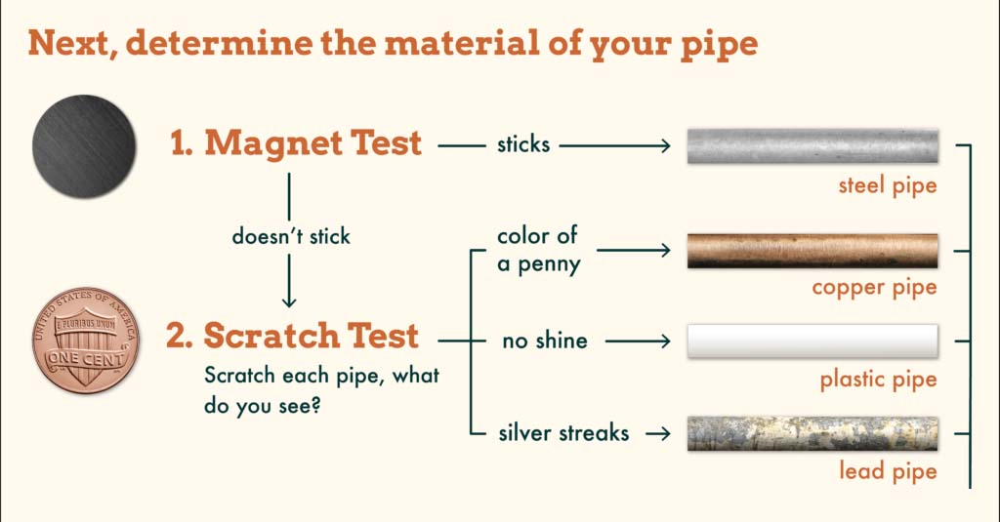
From Crowd that Tap
Appendix B: