Insert Consumer Name and Address

Re: Consumer Notice of Tap Water Lead Testing Result

Dear Consumer:
Insert public water system name is a public water system (PWS) responsible for providing drinking water that meets state and federal standards. Drinking water samples were collected at the following locations. Results are summarized in the table below:
Sample  Tap Location | Sample  Collection Date | Lead Level Result (µg/L) | Greater or Less than the Lead Threshold Level (15 µg/L)
 | ​​Click or tap to enter a date.​
 | ​​Click or tap to enter a date.​
 | ​​Click or tap to enter a date.​
 | ​​Click or tap to enter a date.​
 | ​​Click or tap to enter a date.​
 | ​​Click or tap to enter a date.​
 | ​​Click or tap to enter a date.​
 | ​​Click or tap to enter a date.​
 | ​​Click or tap to enter a date.​
 | ​​Click or tap to enter a date.​

What does this mean?
The Safe Drinking Water Act set the lead action level for lead in drinking water at 15 µg/L. The lead action level measures the effectiveness of corrosion control treatment. It is not a standard for establishing a safe level of lead in a home or building; however, if more than 10% of the locations tested exceed this value, the water system must take action to correct the problem.
When ingested, lead may pose serious health risks, so U.S. EPA established a Maximum Contaminant Level Goal (MCLG) of 0 µg/L for lead. An MCLG is the level of a contaminant in drinking water below which there is no known or expected risk to health, allowing for a margin of safety.
If lead is detected, it may be due to conditions unique to your home or building, such as lead solder or brass faucets, fittings and valves that may contain lead. Our system works to keep the corrosivity of our water as low as possible (corrosive water can allow lead to enter your drinking water from plumbing materials that contain lead). We recommend reviewing the information below to reduce your exposure to lead in drinking water.
What are the health effects of lead?
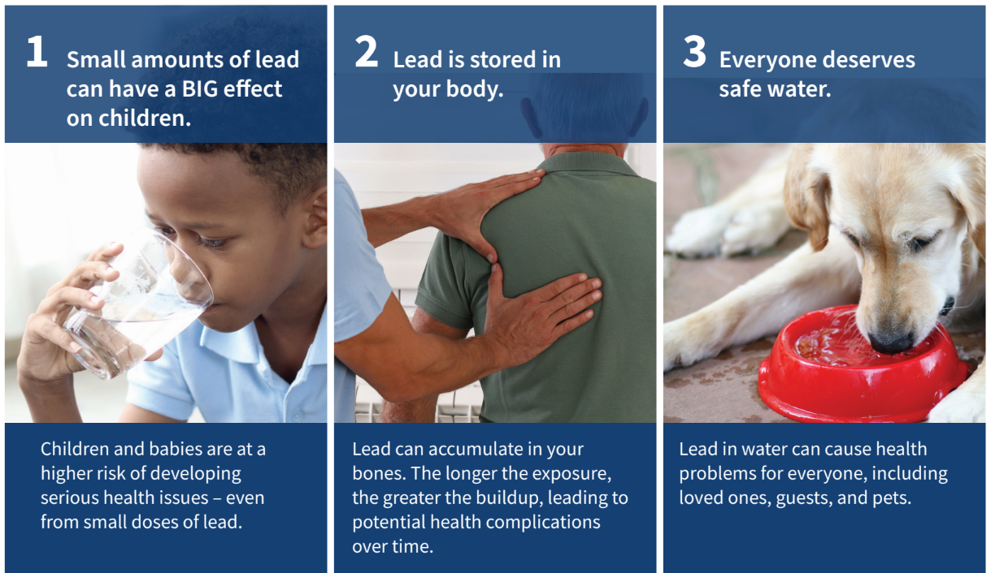
There is no safe level of lead in drinking water. Exposure to lead in drinking water can cause serious health effects in all age groups, especially pregnant people, infants (both formula-fed and breastfed), and young children. Some health effects to infants and children include decreases in IQ and attention span. Lead exposure can also result in new or worsened learning and behavior problems. The children of persons who are exposed to lead before or during pregnancy may be at increased risk of these harmful health effects. Adults have increased risks of heart disease, high blood pressure, kidney or nervous system problems. Contact your healthcare provider for more information about your risks.
Where can I get health screenings for lead?
Health screenings are available through (list agency name[s]) at (list location[s]). They can be contacted at (list phone number(s) and website address(s)/email address(s).

What you can do
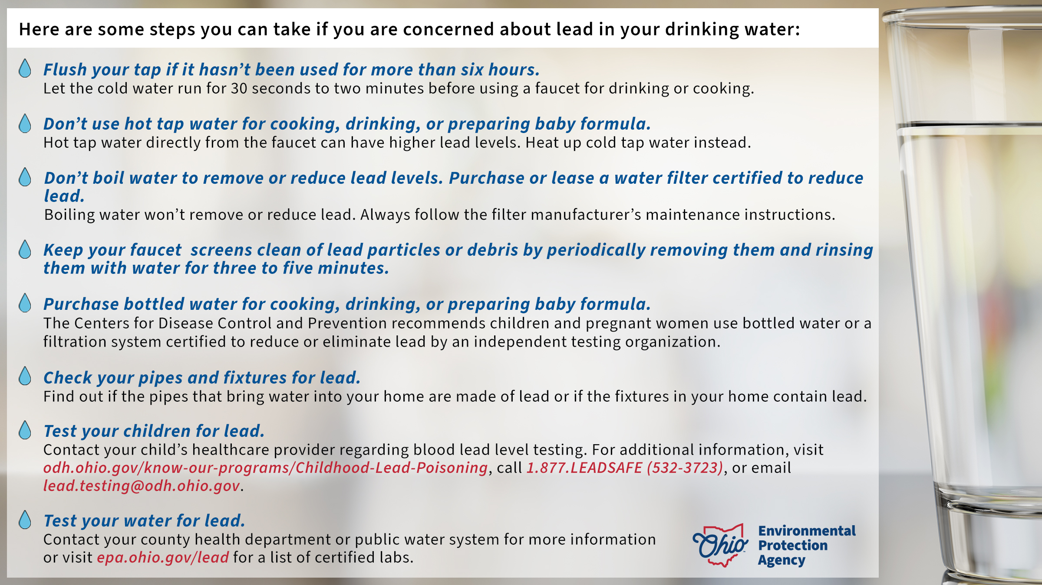

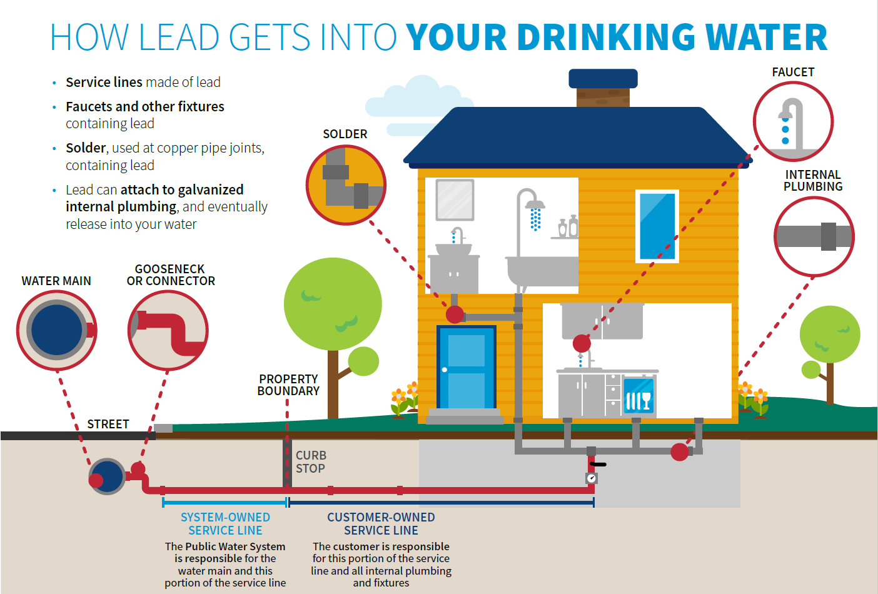
What are the sources of lead?
While lead exposure can occur from various sources, U.S. EPA estimates approximately 20% of human exposure may come from lead in drinking water.

For More Information
Insert contact information for your PWS, visit U.S. EPA’s website at epa.gov/lead, call the National Lead Information Center at 800-424-LEAD, or contact your healthcare provider.

