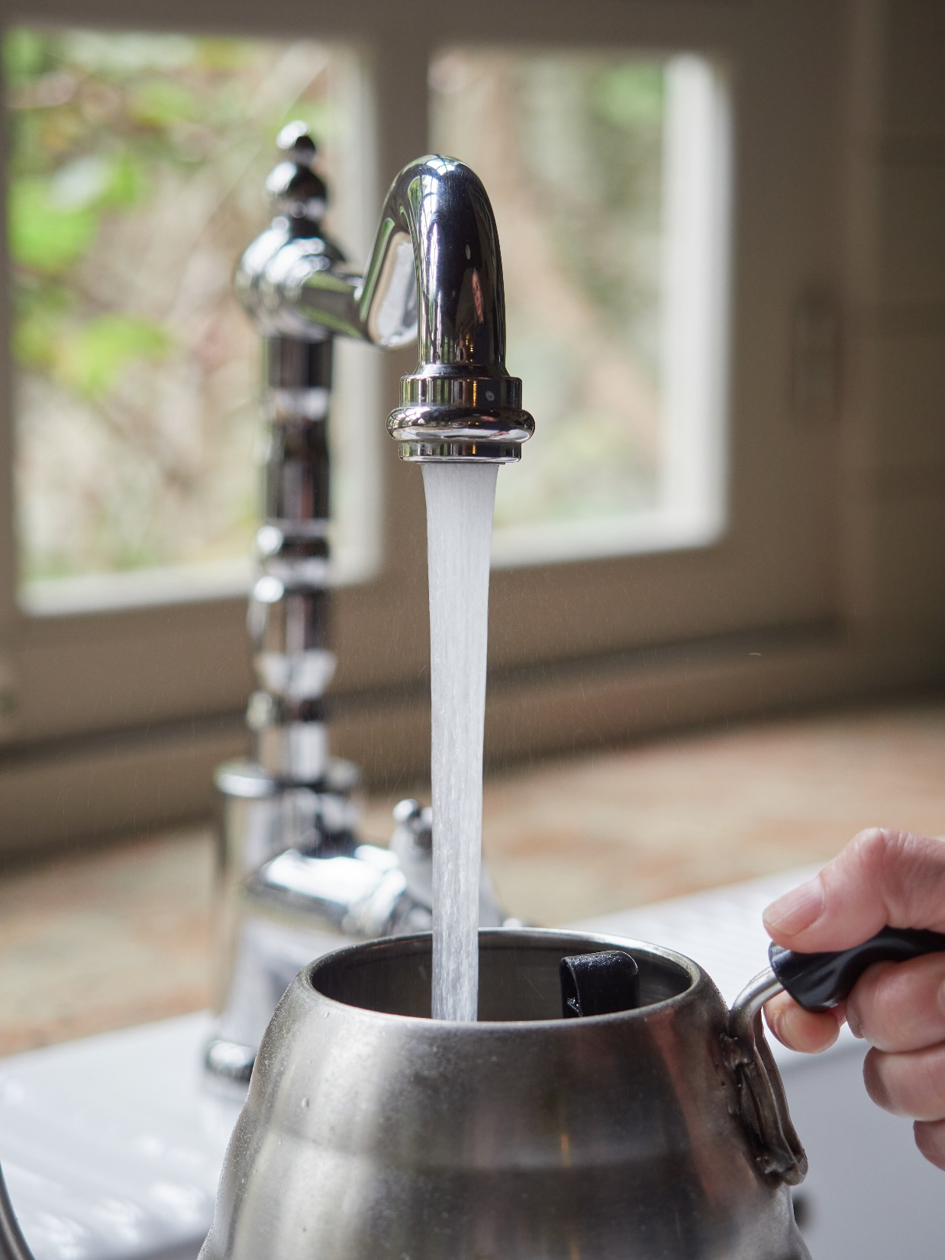
PUBLIC NOTICE OF
LEAD ACTION LEVEL EXCEEDANCE
High levels of lead found in
[PWS NAME] drinking water
At [PWS NAME], we’re committed to ensuring your drinking water is safe. Recently, tests found high lead levels in our drinking water at some homes and/or buildings. We’re taking immediate steps to address this issue. Your health and safety are our top priority.

WHAT HAPPENED
Under the Safe Drinking Water Act, the U.S. EPA determined the lead action level in drinking water to be 15 micrograms per liter (15 µg/L). The lead action level is a measure of the effectiveness of corrosion control treatment. The action level is not a standard for establishing a safe level of lead in a home. A 90th percentile calculation is used to compare sampling results to the lead action level. If the 90th percentile value is above 15 µg/L, this means that more than 10% of the locations tested exceed 15 µg/L resulting in a lead action level exceedance. We, as your water system, are required to take action to correct the exceedance.
From [Month/Year] to [Month/Year], we collected and tested [insert # of samples] samples for lead. Our 90th percentile for lead is [insert 90th percentile] micrograms per liter (µg/L). Of our [insert total # of samples] samples collected, [insert number of samples above action level (15 µg/L)] results were above 15 µg/L.

HEALTH EFFECTS OF LEAD
To inquire about tap water testing, contact [PWS Insert: LAB NAME], [PWS NAME]’s certified laboratory, at [PWS Insert: phone number and/or email].
To have your family tested for lead exposure, call your local county health department or reach out to your family doctor. The Centers for Disease Control and Prevention (CDC) recommends that public health actions be initiated when the level of lead in a child’s blood is 3.5 micrograms per deciliter (μg/dL) or more.
For more information and links to CDC’s website, please visit epa.gov/ground-water-and-drinking-water/basic-information-about-lead-drinking-water.

There is no safe level of lead in drinking water. Exposure to lead in drinking water can cause serious health effects in all age groups, especially pregnant people, infants (both formula-fed and breastfed), and young children. Some health effects to infants and children include decreases in IQ and attention span. Lead exposure can also result in new or worsened learning and behavior problems.
The children of persons who are exposed to lead before or during pregnancy may be at increased risk of these harmful health effects. Adults have increased risks of heart disease, high blood pressure, kidney, or nervous system problems. Contact your healthcare provider for more information about your risks.

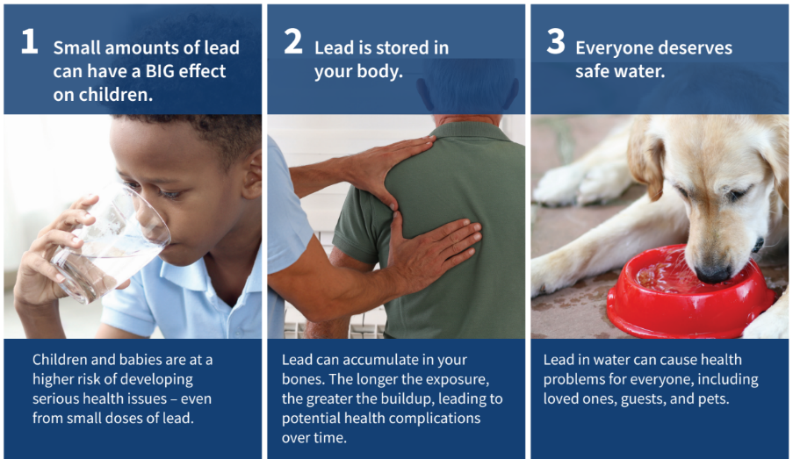

WHAT YOU CAN DO
Listed below are some steps you can take if you are concerned about lead in your drinking water. The list is not intended to be a complete list or to imply that all actions equally reduce lead from drinking water.

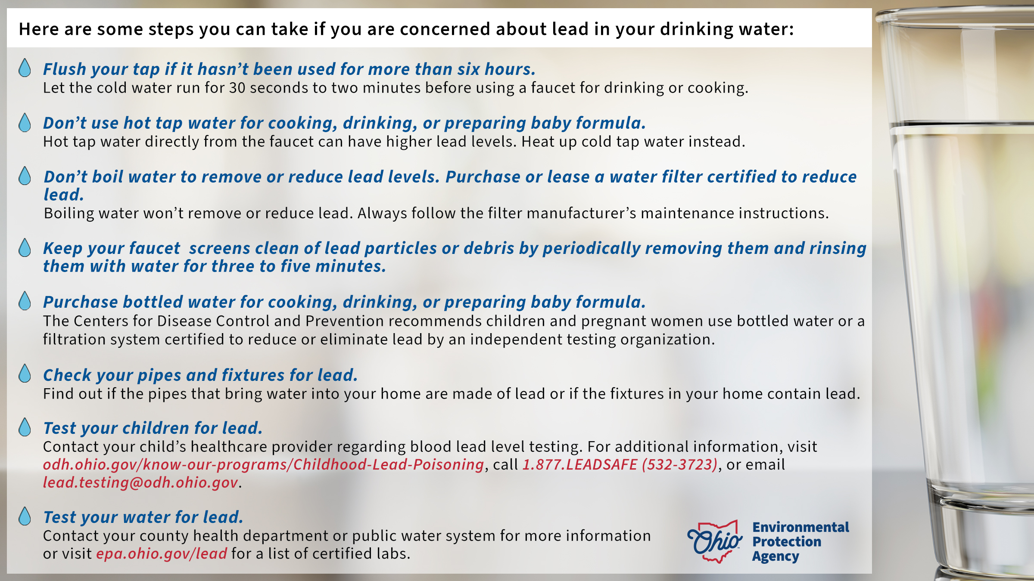
WHAT IS BEING DONE
We are working closely with Ohio EPA to ensure our drinking water is safe. We will send more information by [insert date, 30 business days from receipt of results]. In the meantime, we’re conducting extra lead and water quality monitoring.
[If corrosion control treatment is currently added, consider the following text, otherwise delete:] Corrosion is the primary way lead can get into the water. At the water treatment plant, we use a process called corrosion control which balances the water chemistry to prevent pipes and plumbing from corroding. We are completing an assessment of the corrosion control treatment currently used by our water system. [PWS can insert an approximate timeline for completing this.]
OR
[If corrosion control treatment is NOT currently added, consider the following text, otherwise delete:] We are determining the best corrosion control treatment strategy to resolve this issue. We will send our recommendations to Ohio EPA by [Insert due date for CCT (Small system: 6 Months from last day of MP, Med/Large system: 18 Months from last MP. March 31, June 30, or December 31.]
[If NTNC or very small COM, otherwise delete:] We are investigating and removing lead-containing plumbing materials within the facility (and/or installing water filters at locations impacted by lead-containing plumbing).
[PWS can insert additional actions PWS is taking to resolve/reduce lead, otherwise delete. For example: If you are conducting lead service line replacement, consider adding the following text: We are removing the lead service lines, which is a common source of lead in drinking water.]

MORE INFORMATION
If you have questions or concerns, please contact [PWS Insert: water utility contact name] at [PWS Insert: phone number and/or email] or [PWS insert mailing address].
General guidelines on ways to lessen the risk from lead in drinking water are available on U.S. EPA’s website: epa.gov/ground-water-and-drinking-water/basic-information-about-lead-drinking-water.
Please share this information with all the other people who drink this water, especially those who may not have received this notice directly (for example, people in apartments, nursing homes, schools, and businesses). You can do this by posting this notice publicly or distributing copies by hand or mail.
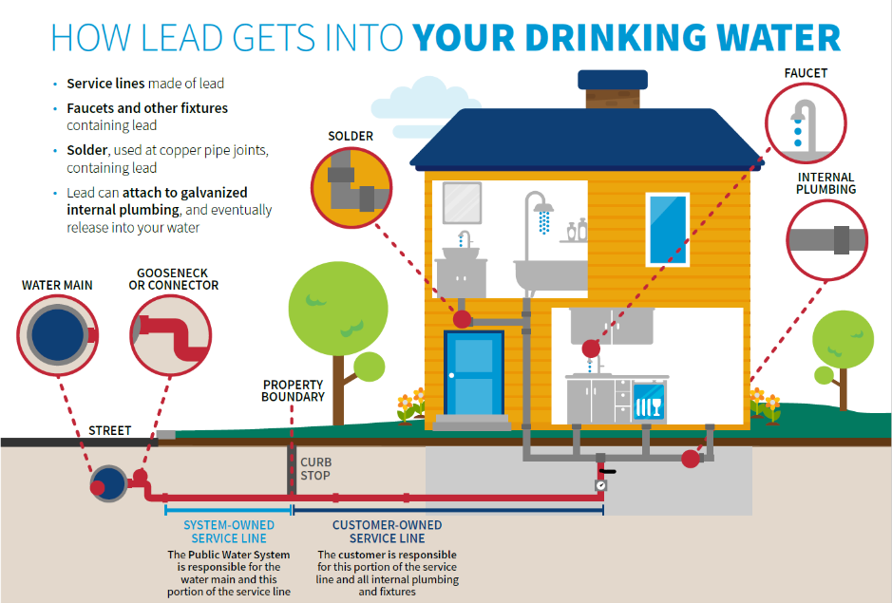
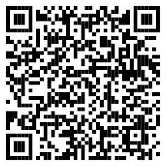
Date distributed: [INSERT DATE]

