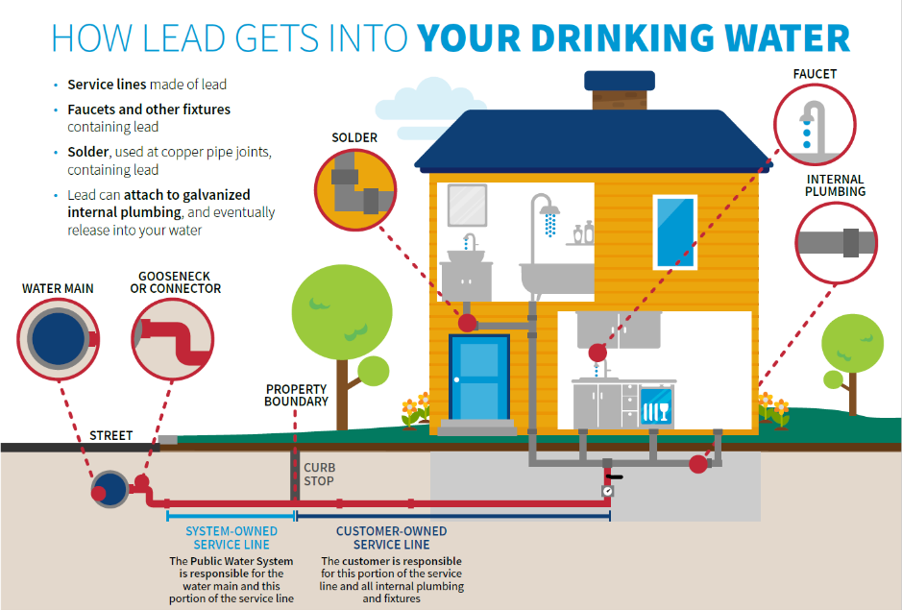
IMPORTANT INFORMATION ABOUT LEAD IN YOUR DRINKING WATER
[INSERT NAME OF WATER SYSTEM] found elevated levels of lead in drinking water in some homes/buildings. Lead can cause serious health problems, especially for pregnant women and young children. Please read this information closely to see what you can do to reduce lead in your drinking water.

HEALTH EFFECTS OF LEAD
There is no safe level of lead in drinking water. Exposure to lead in drinking water can cause serious health effects in all age groups, especially pregnant people, infants (both formula-fed and breastfed), and young children. Some health effects to infants and children include decreases in IQ and attention span. Lead exposure can also result in new or worsened learning and behavior problems. The children of persons who are exposed to lead before or during pregnancy may be at increased risk of these harmful health effects. Adults have increased risks of heart disease, high blood pressure, kidney or nervous system problems. Contact your healthcare provider for more information about your risks.

SOURCES OF LEAD
Lead is a common, toxic, and naturally occurring metal found in many products around our homes. You can find it in things like lead-based paint, air, soil, household dust, food, and certain types of dishes.
While lead is rarely found naturally in water, it can get into drinking water through water distribution systems and plumbing (water service lines, faucets, solder, internal plumbing, etc.). Drinking water isn't the only source of lead poisoning, but it can add to the total amount of lead a person ingests.
Other common sources include lead-based paint (especially in homes built before 1978), soil, and dust. Kids can get lead poisoning by accidentally swallowing paint chips or dust containing lead.
WHAT YOU CAN DO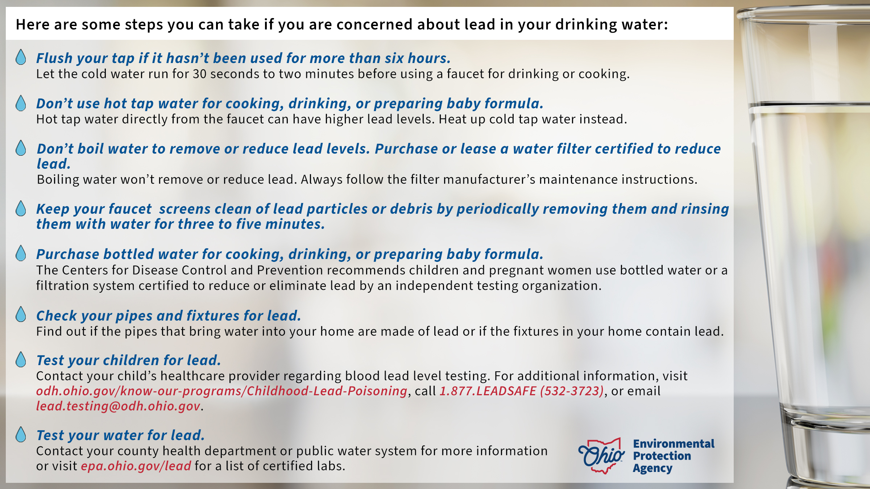

WHAT IS {Municipality} DOING TO REDUCE LEAD LEVELS
[Insert reason why there are elevated levels of lead in the system’s drinking water (if known) and what the system is doing to reduce the lead levels]

MORE INFORMATION
For more information, call us at [INSERT YOUR NUMBER] or (IF APPLICABLE visit our website at [INSERT YOUR WEB SITE HERE]).
For more information on reducing lead exposure around your home/building and the health effects of lead, visit U.S. EPA’s website at epa.gov/lead or contact your healthcare provider.

LABORATORY RESULTS
[INSERT ANALYSIS OF COMPLIANCE SAMPLES, FOR EXAMPLE: PWS Name exceeded the action level with a 90th percentile of 20 parts per billion (ppb). Ten samples were taken. The following table summarizes the lead sampling results.
Sample ID | Lead Result (ppb)
LC201 | 25
LC202 | <5
LC203 | <5
LC204 | 7
LC205 | <5
LC206 | <5
LC207 | <5
LC208 | <5
LC209 | 20
LC210 | 20
OR
FOR EXAMPLE: PWS Name exceeded the action level with a 90th percentile of 20 parts per billion (ppb). Ten samples were taken and resulted in the following lead levels: six samples had results less than 5 ppb, one sample had a result of 7 ppb, two samples were 20 ppb and one sample had a result of 25 ppb.]

