Instructions
Source Water Protection Plan - Template

This guide explains how to use Ohio EPA’s Template to create your Source Water Protection Plan (SWPP). Portions of the template contain standard language provided for your use with minor or no modification needed; however, you should provide as much detail as necessary throughout the plan to address the source water protection concerns and needs unique to your community.

Source Water Assessment Report
(Technical Information)
Source Water Protection Plan
(Protective Strategy Information)

Education/
Outreach
Future Planning and Source Sustainability
Contaminant Source Control Strategies
Source Water Monitoring (opt.)
Delineation
Inventory
Susceptibility Analysis
Protected Source of Drinking Water
+
=

To start working on your SWPP, replace items in the template highlighted in yellow with information specific to your community and/or public water system (PWS). Fill out all tables as completely as possible. Some examples are provided in the tables, but you can find more details on Ohio EPA’s Source Water Assessment and Protection (SWAP) Program website. This includes protection planning guidance specific to both groundwater and surface water public water systems. For further assistance, contact your Ohio EPA District office and ask for the SWAP staff, or call the Ohio EPA Central Office at 614.644.2752.

Ohio EPA developed educational materials such as videos, posters, and coloring books that can be used to inform the public about source water protection. These materials can be found on Ohio EPA’s Source Water Assessment and Protection Program webpage by selecting the dropdown for Publications and Resources, then Educational Materials. Please note, there are many other source water protection related resources available online. We recommend researching what resources will work best for your system and encourage you to utilize these resources during implementation of your source water protection plan. Visit our website here: Source Water Assessment and Protection Program | Ohio Environmental Protection Agency.

SECTION 1 – INTRODUCTION

Section 1 identifies your community’s source of drinking water and identifies the source water protection area. Replace yellow-highlighted text with text appropriate to your system. You should reference the most up to date version of your Source Water Assessment Report and include a copy in Appendix A. **If your report is older than 10 years, please contact Ohio EPA staff to assist with updating it before drafting your protection plan.

SECTION 2 – PARTNERSHIPS and FORMING A PROTECTION TEAM

The goal of Section 2 is to list partners that will provide valuable resources for your system’s protection planning efforts. These partners may include organizations which assist in different ways, such as: providing information, spreading awareness, reducing costs, and implementing protective strategies. They share a common goal to support activities aimed at safeguarding, maintaining, or improving water quality. Potential partners could include other city/village staff, local government representatives, county health departments, local soil and water conservation districts and emergency responders, but are not limited to the suggestions listed in the template.

Many local organizations might already be implementing source water protection strategies on their own! For example, county health departments often inspect private septic systems, but they might not be aware of your source water protection area. The soil and water conservation district might be able to prioritize outreach in your corridor management zone or one-year time of travel. Involving other organizations in your source water protection program can increase the number of protective strategies that are implemented and strengthen relationships within the local community, all while reducing the amount of work that public water systems must do! Fill in Table 2-1 with any organizations that will help your public water system implement source water protection strategies (edit or delete examples as needed).

Appendix B includes example language to draft a resolution if your community would like to create an ordinance in support of the protection planning efforts. Although this is NOT a requirement of the protection planning document, it demonstrates that the community recognizes and supports source water protection activities. Delete references to the resolution in the SWPP if your community did not draft a resolution and remove Appendix B.

SECTION 3 – POTENTIAL CONTAMINANT SOURCE CONTROL STRATEGIES

The goal of Section 3 is to prioritize potential contaminant sources identified in your Source Water Assessment Report. By determining what sources pose the most risk, it helps focus protection planning efforts when resources may be limited. Fill in Table 3-1 utilizing the information in your Source Water Assessment Report (Appendix A). The following graphic provides examples of potential contaminant sources and the organizations that regulate them (in parentheses). Consider reaching out to these organizations to address specific potential contaminant sources.
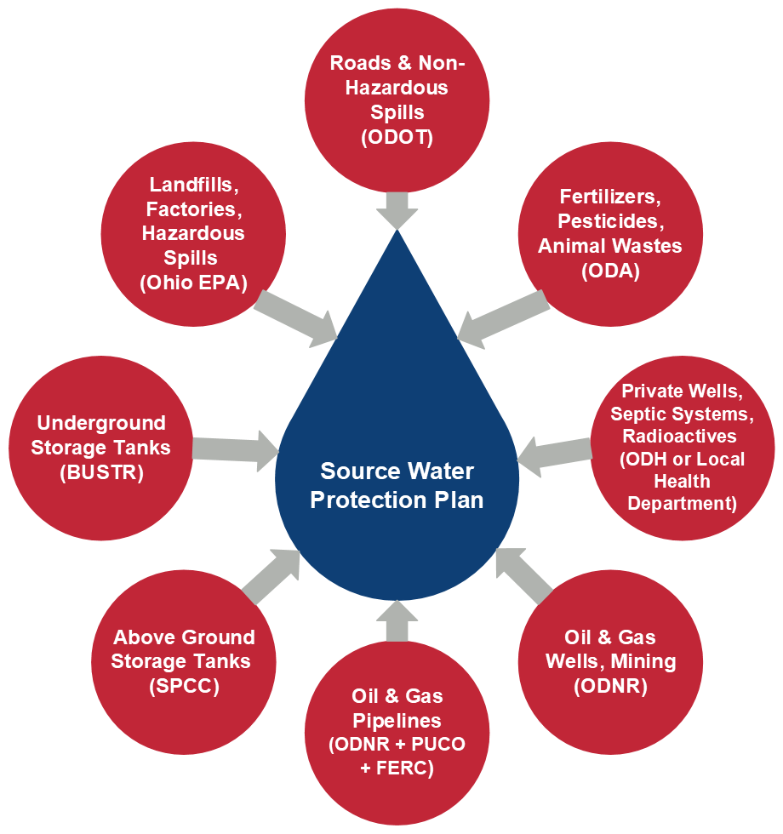

Steps to complete the Table 3-1:
- Using your Source Water Assessment Report and your knowledge of the area, list the potential contaminant sources in your protection area. Rank them based on priority and/or level of threat as High, Moderate, or Low. Sources/activities should be ranked higher if they are located close to your wells or intakes, if they involve large quantities or concentrations of toxic chemicals, and or if the facility has a history of mishandling chemicals, etc. (keep in mind that rankings can change over time; however, they are helpful to prioritize protective strategies).
- Identify the strategies the community will use to protect its drinking water from the types of potential contaminant sources identified.
- List the organization and position/title that will be responsible for implementing or tracking implementation of the strategy. This will help assign accountability to ensure the strategy is implemented.
- Indicate the timeline for implementing this strategy. If the strategy is a one-time effort, the timeline should be “by [date]’ or “completed, [date]”. If the strategy is completed periodically, the timeline should be “by [date], and every x year(s)” or something similar.

Tip: Examples are given in Table 3-1 below. You can copy these directly into the template or edit and delete them as you see fit.

Table 3-1: Example Source Control Strategies
Potential Contaminant Source | Priority/ Level of Threat | Protective Strategies/Proposed Actions | Organization (Position/Title) | Implementation Timeline
Fire Training Center | High or Moderate or Low | Prohibit or Restrict the use of AFFF.  Replace AFFF with more environmentally friendly foam.  Close or Relocate fire training areas. | Position/Title - (Do not include Employee Name) | Month/Year, ongoing
Regulated Substances | High or Moderate or Low | Restrict Quantities that can be stored in DWSPA Establish local ordinance or inspection program | Position/Title - (Do not include Employee Name) | Month/Year, ongoing
High Priority Commercial and/or Industrial Source | High or Moderate or Low | Establish Communication, point of contact for the facility.  Incorporate SWAP area and PWS communication into any emergency plans at the facility. | Position/Title - (Do not include Employee Name) | Month/Year, ongoing
Erosion, Urban sprawl | High or Moderate or Low | Buy land adjacent to and in the DWSPA to protect area from future industrial facility growth.  Implement Design Standards to prevent erosion | Position/Title - (Do not include Employee Name) | Month/Year, ongoing
Petroleum Hydrocarbons | High or Moderate or Low | Implement Design standards to control potential contaminated surface water runoff  Require Reporting and Documentation of known/suspected spills and releases | Position/Title - (Do not include Employee Name) | Month/Year, ongoing
All Sources | High or Moderate or Low | Protection Team Meetings | Position/Title - (Do not include Employee Name) | Month/Year, ongoing
All Sources | High or Moderate or Low | Include Source Water Protection information in water bills | Position/Title - (Do not include Employee Name) | Month/Year, ongoing
All Sources | High or Moderate or Low | Include source water protection information in Consumer Confidence Report (CCR) | Position/Title - (Do not include Employee Name) | Month/Year, ongoing
All sources | High or Moderate or Low | Create Source Water Protection Website | Position/Title - (Do not include Employee Name) | Month/Year, ongoing
Transportation | High or Moderate or Low | Install Road Signs  SR 123 at Main Street  SR 456 at Main Street  Install Spill Containment Basins/Berms  SR 123 at Main Street | Position/Title - (Do not include Employee Name) | Month/Year, ongoing
Spills, Releases | High or Moderate or Low | Employee Training for preventing and responding to spills in Source Water Protection Area | Position/Title - (Do not include Employee Name) | Month/Year, ongoing
All sources | High or Moderate or Low | Conduct Water Treatment Plant Tours | Position/Title - (Do not include Employee Name) | Month/Year, ongoing
Storm Run-off | High or Moderate or Low | Install Storm Drain Signs  Along Rt 123 | Position/Title - (Do not include Employee Name) | Month/Year, ongoing

SECTION 4 – EDUCATION AND OUTREACH

The goal of Section 4 is to develop strategies that educate your community about the benefits of protecting their drinking water source from contamination. Ohio EPA has example educational materials including videos, posters, and coloring books that can be used to inform the public about source water protection. These materials can be found on Ohio EPA’s Source Water Assessment and Protection Program page by selecting the dropdown for Publications and Resources, then Educational Materials.

Visit our website here: Source Water Assessment and Protection Program | Ohio Environmental Protection Agency.

The following graphic discusses WHO needs to be educated about source water protection and WHY they need this information. It also provides some example strategies to help reach your target audiences. This list is not all-inclusive; feel free to propose strategies other than what is here to fill out Table 4-1.

Educating the Public Officials – Public officials should understand and support protection planning efforts because they can be key figures in providing resources to develop and implement strategies as well as promoting the protection plan.
Who? - Police and fire departments, EMS, Township Trustees, City Council, County Commissioners
How? – Meet to review where the drinking water comes from (SWAP report) and discuss protection planning. Obtain feedback on protective strategies.
Educating the General Community
Educating the general community helps to obtain the acceptance and support that will enable community leaders to proceed.

How?
–Tours of Water Treatment Plant
-Information on Social Media and website
–Postings in public areas
–Articles in local newspapers, newsletters
–Brochures about SWAP
–Public Educational Meetings
–Presentations before local groups, schools,
-Booth at local festivals
–Discussions on radio and local TV shows

Educating People who live and work in the protection area
People who live and work in the protection area should be aware of how their activities can impact their source of drinking water and what they can do to prevent contamination.

How?
–Enclosures with the water bill or CCR
–Posters in the workplace
–Employee awareness training
–Signs along transportation routes in the protection area
–Letters to businesses/residents in the area
–Brochures in stores that inform customers how to safely dispose of hazardous products
–Signs in public areas (libraries, parks)

Steps to complete the Table 4-1:
- Identify the educational strategies the community will use to make folks aware of the source water protection area and what they can do to reduce the risk of it becoming contaminated.
- Indicate the target audience for this strategy. For example, your strategies may focus primarily on water customers (e.g., CCR), or on students (e.g., inviting schools to tour the water treatment plant) or the public at large (e.g., road signs).
- List the position (by title) who will be responsible for implementing—or tracking implementation of—the strategy (avoid the use of names since that position might be held by more than one person over time). This will help assign accountability to ensure the strategy gets implemented.
- Indicate the timeline for implementing each strategy. Most educational strategies need to be repeated periodically to be effective. If the strategy will be repeated periodically, timeline should be something like “by [date], and every x year(s) thereafter”. If the strategy is a one-time effort, timeline should be “by [date]” or “completed, [date]”.

Table 4-1. Example Educational Strategies
Education and Outreach Strategies | Target Audience | Organization (Position/Title) | Implementation Timeline
Consumer Confidence Report – include information about actions residents can take to protect source water quality | Water customers | PWS Operator | Distribute annually, in Month
Water Plant Tours – Open House or Scheduled Tours | Students, Community | PWS Operator | Open House - Month 20XX and every year after  Scheduled Tours – as requested
[SYSTEM] Source Water Protection Website | General Public | Please specify | Please specify
[SYSTEM] Social Media Page – (Please specify Facebook, Twitter, Instagram, etc.) | General Public | Please specify | Please specify
Local School District  - Display sand tank and/or EnviroScape model(s) | Students | Local science teacher or Soil and Water Conservation District | Please specify
Distributing source water Brochures (during tours, with CCRs, during events etc.) created by Ohio EPA | Students, Consumers, General Public | Ohio EPA and PWS Operator | Please specify
Inform local emergency first responders on an annual basis of the location of the Source Water Protection Area | EMA, Fire Department | Fire Chief | Organized annually, in Month
Provide educational programs and host events for residents on-site or at local community spaces like libraries or public park welcome centers to engage residents and raise awareness of source water protection | General Public | Local Businesses, Health Department, Village Event Coordinator | Hosted annually in the summer starting in Month 20XX and every year after
Conduct annual meetings with local council members to discuss any issues related to Source Water Protection | Village Council | Village Council and PWS Operator | Hosted annually in Month 20XX and every year after
Regularly collaborate with neighboring water suppliers to discuss relevant issues in source water protection | Village of XYZ | Village of XYZ Operator and PWS Operator | Please Specify
Host information booths at community events like county fairs and festivals | General Public | Soil and Water Conservation District | Annually in Month 20XX and every year after
Collaborate with local parks to incorporate source water protection education at water-related events such as fishing, kayaking, etc. | Students, General Public | Parks and Rec Event Coordinator | Biannually in the summer and fall
Provide educational materials to local businesses regarding potential contaminant sources and their impacts on ground water | XYZ Industries, etc. | Natural Resource Conservation Services and PWS Operator | Distribute annually in Month 20XX and every year after
Create/maintain and advertise internship opportunities for high school students interested in the water industry | High School Students | PWS Operator | Please Specify

SECTION 5 – FUTURE PLANNING FOR SOURCE WATER SUSTAINABILITY

The goal of Section 5 is to assess the sustainability of the drinking water source, which is a critical asset for every community. The Source Water Protection Plan should work in concert with the Asset Management Plan (referenced in Ohio Administrative Code (OAC) 3745-87). Please include the Source Water Protection Plan as part of your comprehensive Asset Management Program. Be sure to include the date for the most recent update. Additionally, all community public water systems are required to have a Contingency Plan (referenced in OAC 3745-85-01) that addresses emergencies such as a power outage, flooding, tornado/storm damage, discovery of contamination in the source water or finished water, depressurization, etc. Please include the date for the most recent update of the Contingency Plan. Keep in mind that contingency plans do not address all the topics that are important for source water protection, such as:

1) Long-term loss of source
2) Planning for future growth and additional capacity (i.e., installing new wells in areas that meet siting criteria)

Therefore, systems are encouraged to be proactive regarding source water protection and include details regarding potential growth and evaluation of the sustainability of the source water resources within the context of the potential long-term loss of source and/or future source needs.
Utilize the following to help determine if your current drinking water source is sustainable or if additional resources may be necessary for the future. The system is currently pumping about ____% (A/B) of its design capacity and ___% (A/C) of its source capacity.
- Current average daily pumpage = ________ gallons per day
- Current daily system design capacity = ________ gallons per day
- Source capacity (the maximum amount the wells/intakes can pump (based on the capacity of the pumps and/or limitations of the source water aquifer) is __________ gallons per day.

If you determine that the system’s source water is sustainable for the future and additional resources are NOT needed, please complete OPTION A and delete OPTION B. Sample language is provided in the template.

If you determine that the system’s source water may not be sustainable due to anticipated growth in consumption, asset vulnerability, and/or inadequate supplemental capacity, please complete OPTION B and delete OPTION A. Examples are provided in the template.

SECTION 6 – SOURCE WATER MONITORING

The goal of Section 6 is to assess the need for source water monitoring and if needed, summarize a monitoring plan. Source water monitoring is not always necessary, but it may serve as an early warning of an impacted source. It may also provide information that leads to effective protective strategies that can reduce the potential for future impairment. Ohio EPA SWAP staff can help with the development of a source water monitoring plan.

The need for source water monitoring depends on the following:
- the susceptibility of the drinking water source,
- the presence of potential contaminant sources and/or existing water quality impacts

Consider the following:
- Do you have water quality impacts, even at low levels?
- Do you know the source of these impacts?
- Are there sources with a high potential for spills or releases near your drinking water source?
- Have there been spills or releases historically in your protection area?
- Is there an active environmental cleanup in or near your protection area?

Source water monitoring can include review of data obtained by other parties, including reports submitted to regulatory agencies. These may include sampling reports from active underground storage tank cleanups, monitoring reports from landfills, reports related to hazardous waste cleanups, or biological and water quality surveys performed by Ohio EPA’s Division of Surface Water.

If you determine that source water monitoring is not needed, please complete OPTION A and delete OPTION B. Sample language is provided in the template to help you get started.

If you determine that source water monitoring is needed, please complete OPTION B and delete OPTION A. Fill out Table 6-1 for each sampling location in your monitoring network. Examples are provided in the template. You should also include a copy of your source water monitoring plan in Appendix D.

SECTION 7 – PERIODIC REVIEW, IMPLEMENTATION & UPDATES

The system’s Drinking Water Source Protection Plan, as well as the SWAP Assessment Report, need to be reviewed periodically and updated in accordance with OAC Rule 3745-87-03(B)(6). Ohio EPA reviews implementation activity at least every three years; typically, at the same time the system’s contingency plan is reviewed. It may also provide evidence of the success (or failure) of those strategies. Success can be translated into continued support, and failure can lead to finding a more effective strategy.

7.1 Review of the SWAP Report and Protection Plan
Community and non-transient non-community public water systems shall review the source water assessment report annually to determine if revisions are necessary. This helps ensure that the protection area is representative of current pumping rates and potential contaminant sources are accurate, which subsequently helps ensure that protective strategies are relevant.

Community and non-transient non-community public water systems that have an endorsed drinking water source protection plan shall review the protection plan in accordance with any stated review schedule. If no schedule has been defined, it must be reviewed at least every three years. Public water systems that have a drinking water source protection checklist that has been submitted and accepted by Ohio EPA shall review and update the checklist at a minimum of every five years. A revised drinking water source protection plan or checklist shall be submitted to Ohio EPA within sixty days of making the revisions, in accordance with OAC Rule 3745-87-03(B)(6)(e).

Section 7-2 Signature and Date
To demonstrate the system’s commitment to maintaining the protection plan as a dynamic document that is representative of current and future needs, please identify, by name, the person responsible for reviewing the plan and a timeline for implementation of the review documented by a signature and date, utilizing the provided log for tracking purposes.

APPENDICIES

Appendix A. Ohio EPA requires that you attach a copy of an up-to-date SWAP Assessment Report.

Appendix B. If your community passed an ordinance to create a drinking water source protection plan, you should attach a copy of the resolution (if applicable).

Appendix C. Educational Outreach materials. Many communities attach a copy of their local SWAP brochure, example letters addressed to local businesses or residents, or local press releases.

Appendix D. Source Water Monitoring Plan (if applicable)

Appendix E. Additional Resources and/or Reference Material (if applicable)

