**OHIO FAMILY AND CHILDREN FIRST OVERVIEW**

Ohio Family and Children First started as an initiative of the Office of the Governor in 1991, before being codified in 1993, along with the 88 local family and children first councils. Ohio Family and Children First was created in statute (ORC 121.37) by streamlining and coordinating existing services for families needing assistance for their children.

The Ohio Family and Children First Cabinet is comprised of the following state-level leadership:  [Aging](https://aging.ohio.gov/), [Developmental Disabilities](https://dodd.ohio.gov/home/), [Children and Youth](https://childrenandyouth.ohio.gov/home), [Education & Workforce](https://education.ohio.gov/), [Health](https://odh.ohio.gov/home), [Job and Family Services](https://jfs.ohio.gov/), [Medicaid](https://medicaid.ohio.gov/HOME.aspx), [Mental Health and Addiction Services](https://mha.ohio.gov/), [Opportunities for Ohioans with Disabilities](https://ood.ohio.gov/), [Rehabilitation and Correction](https://drc.ohio.gov/), [Youth Services](https://dys.ohio.gov/), and the [Office of Budget and Management](https://obm.ohio.gov/).

These entities oversee and fund the work of the Ohio Family and Children First state office, comprised of six state staff, who then monitor and oversee the work of the 88 local family and children first councils. Locally, the commissioners establish the 88 county Family and Children First Councils (FCFCs) comprised of mandated membership to include the following representatives or designees from the following:

Local mental health board Board of county commissioners

City/county health district Early intervention collaborative

County job and family services agency Department of Youth Services

County public children services agency Head start program representative

Developmental disabilities board Juvenile court

Community school districts Caregivers who have received services from the local council

Local municipal corporations Non-profit agencies and other local members as identified by the council

**4 Core functions of Family and Children First Councils**

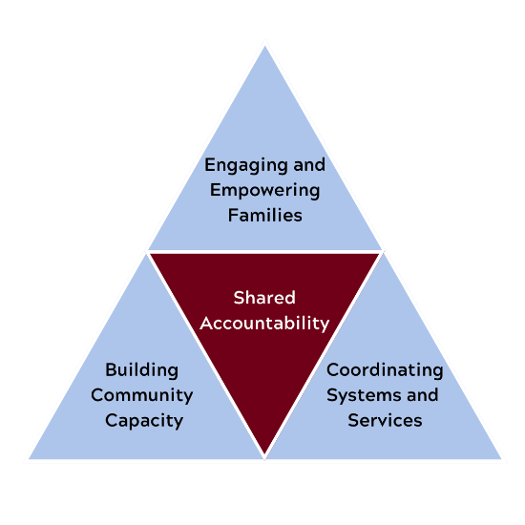

* [**Coordinating Systems and Services**](https://fcf.ohio.gov/core-functions/coordinating-services/coordinating-services) - Service coordination provides a process for families with multiple and complex problems to effectively address their needs that creates a unique intervention/ treatment environment which eliminates duplication and provides both traditional services and builds natural supports. Visit [**here**](https://fcf.ohio.gov/about/find-your-fcfc) for contact information to reach your county FCFC.
* [**Engaging and Empowering** **Families**](https://fcf.ohio.gov/core-functions/engaging-and-empowering-families/engaging-and-empowering-families) – Parents are recruited and supported to be active contributing members on county FCFCs, to be involved in key decision-making efforts, and to serve as an advocate for children, families, and communities.
* [**Building Capacity**](https://fcf.ohio.gov/core-functions/building-community-capacity/building-community-capacity) – County councils work together to identify and address the ongoing needs of children and families through planning, implementing effective strategies, monitoring, and reporting, and evaluating progress toward achieving desired outcomes.
* [**Shared Accountability**](https://fcf.ohio.gov/core-functions/shared-accountability/01-shared-accountability) – An infrastructure is governed and supported to allow for creative and innovative solutions that will streamline and strengthen the local delivery system for children and families.