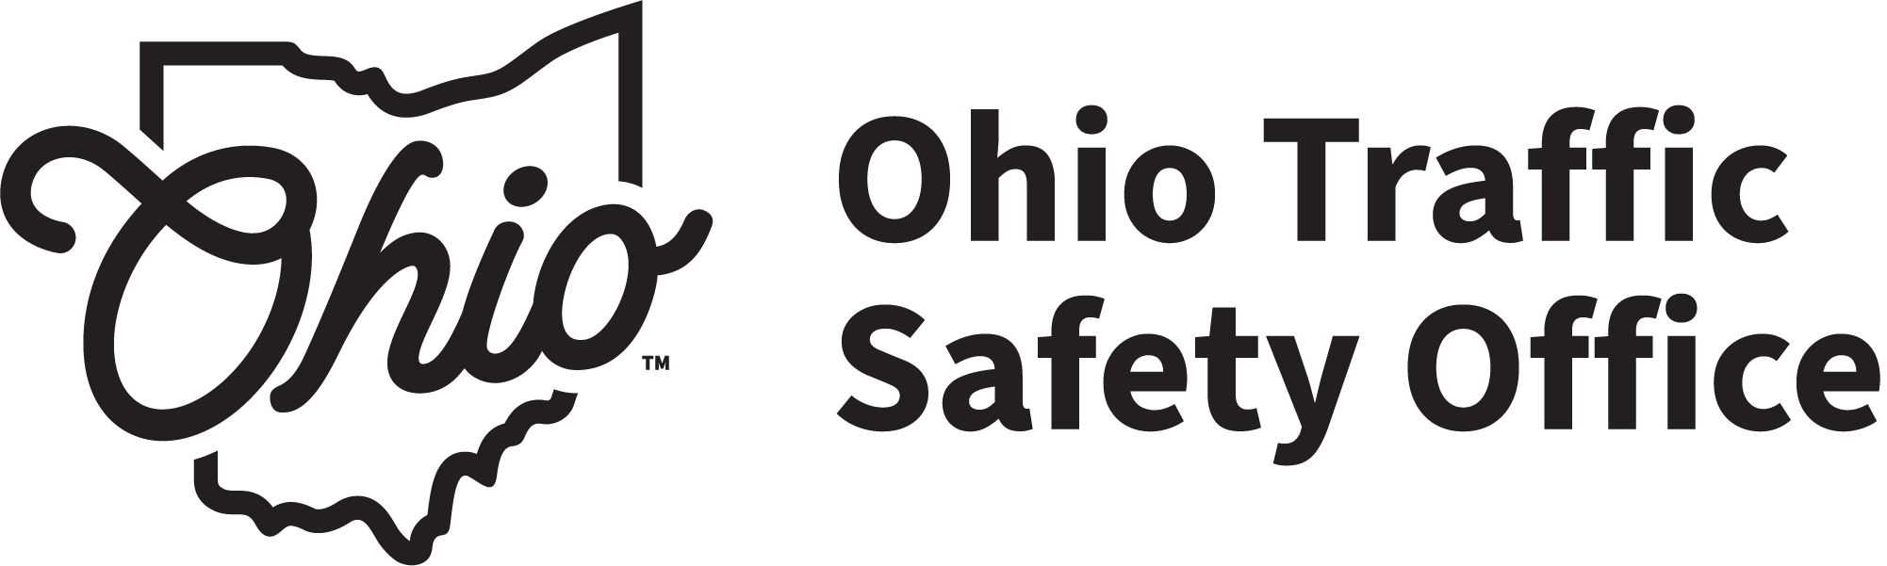 | OHIO DEPARTMENT OF PUBLIC SAFETY  DRIVER TRAINING  MOTOR VEHICLE INSPECTION LIST

The most current version of this document available at www.drivertraining.ohio.gov
Ohio Administrative Code (O.A.C.) requirement: Every motor vehicle used by the school shall be inspected annually. No motor vehicle shall be used for driver training unless it has passed an inspection and has been added to the list of vehicles.
List all motor vehicles used for driver training with this driving school at any time during the report year. If additional pages are needed, photocopy this page and attach any additional pages to the back of this report. Please type all information.
REPORT YEAR |  | ENTERPRISE NAME |  |  | ENTERPRISE #
YEAR OF VEHICLE | MAKE | VIN  (LAST 6) | VEHICLE UNIT NUMBER | LICENSE PLATE # | DATE INSPECTED | CVSA / INSPECTION # | INSPECTOR INITIAL
This form is required per O.A.C. 4501-7-14, 4501-7-31, and 4501-8-13.

