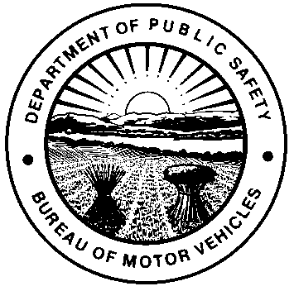 | OHIO DEPARTMENT OF PUBLIC SAFETY  BUREAU OF MOTOR VEHICLES  CERTIFICATE OF COMPLIANCE  Section 4517.24 of the Ohio Revised Code (R.C.)
Shared business street address

CITY |  | STATE | ZIP CODE
COUNTY

BUSINESS NAME (Complete Section A) |  |  |  | PERMIT #
BUSINESS NAME (Complete Section B) |  |  |  | PERMIT #
The purpose of this form is to confirm that the two licensed motor vehicle dealerships listed on this form are engaged in business at the same location, as permitted by R.C. 4517.24, and agree to the following:
- To be jointly, severally, and personally liable for any liability arising from their engaging in the business at the same location;
- That no more than two licensed motor vehicle dealerships will be engaging in business at this same location;
- That both licensed dealerships meet and will maintain compliance with the physical requirements as pursuant to section 4501:1-3-08 of the Ohio Administrative Code and that the location shall clearly portray that it is being maintained by two separate dealerships at all times;
- That each licensed dealership has and will maintain separate inventories at all times, shall not offer for sale any motor vehicle belonging to the other dealership, and shall maintain their own records, business hours, and salespersons;
- That notification will be sent to the Registrar of Motor Vehicles regarding changes to personnel of owners and / or location of business within 15 days of the change, pursuant to R.C. 4517.23;
- That it is understood that failure to comply with all licensing requirements may result in one or both licenses being suspended or revoked by the Motor Vehicle Dealers Board.
SECTION A
I, as sole proprietor, partner, president, member, or trustee of the business entity, acknowledge that all the information is true and accurate.
BUSINESS NAME |  |  |  |  | PERMIT #
PRINTED OR TYPED NAME OF SIGNER |  |  |  |  | TITLE
SIGNATURE (MUST BE SIGNED IN FRONT OF A NOTARY)  X |  |  |  |  | DATE
NOTARY
Sworn to and subscribed in my presence this day of , 20
in County, State of .

(Notary Seal)

Signature of Notary / Clerk / Deputy Clerk (circle one) X
My commission expires

SECTION B

I, as sole proprietor, partner, president, member, or trustee of the business entity, acknowledge that all the information is true and accurate.
BUSINESS NAME | PERMIT #
PRINTED OR TYPED NAME OF SIGNER | TITLE
SIGNATURE (MUST BE SIGNED IN FRONT OF A NOTARY)  X | DATE
NOTARY
Sworn to and subscribed in my presence this day of , 20
in County, State of .

(Notary Seal)

Signature of Notary / Clerk / Deputy Clerk (circle one) X
My commission expires

RETURN THE COMPLETED APPLICATION TO:

Ohio Bureau of Motor Vehicles
Attention: Dealer Licensing Section
P.O. Box 16521
Columbus, Ohio 43216-6521

For additional information and all applicable laws visit our Web site at OhioAutoDealers.com.

