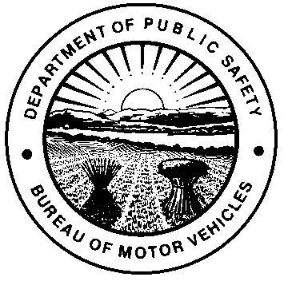 | OHIO DEPARTMENT OF PUBLIC SAFETY  BUREAU OF MOTOR VEHICLES  APPLICATION FOR EXEMPTION FROM PAYMENT OF PERMISSIVE  TAX BY NON-RESIDENT MEMBER OF THE ARMED FORCES  Ohio Revised Code (R.C.) 4504.09
APPLICANT INFORMATION
OWNER FIRST NAME |  | LAST NAME |  |  | MI
OHIO RESIDENT ADDRESS

CITY |  | STATE | ZIP CODE
MILITARY ADDRESS

CITY |  | STATE | ZIP CODE
BRANCH OF SERVICE |  | SERVICE #
LEGAL RESIDENCE

CITY |  | STATE | ZIP CODE
LICENSE PLATE NUMBER
VEHICLE 1 |  | VEHICLE 2
VEHICLE 3 |  | VEHICLE 4
I understand the penalty as covered in section 2913.42 of the R.C., which concerns making a false statement on an application.
E-MAIL ADDRESS |  |  |  | TELEPHONE NUMBER
APPLICANT SIGNATURE  X |  |  |  | DATE
CERTIFICATION
I, the undersigned, certify that the above-named individual is not a legal resident of Ohio (his/her legal state of residence is shown above).
COMMANDING OR PERSONNEL OFFICER SIGNATURE  X |  |  |  | DATE
THIS FORM IS TO BE COMPLETED ONLY WHEN THE ABOVE APPLICANT IS NOT A LEGAL RESIDENT OF OHIO, BUT IS CURRENTLY STATIONED IN OHIO PER R.C. 4503.111(C)(3)

