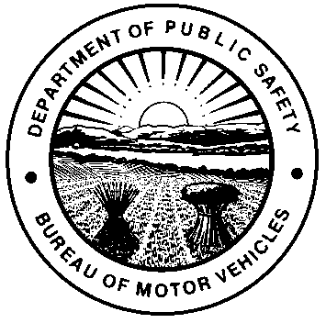 | OHIO DEPARTMENT OF PUBLIC SAFETY  BUREAU OF MOTOR VEHICLES  DRIVER TRAINING WAIVER
This form must be completed to meet the driver training waiver exemptions established by Ohio Revised Code (R.C.) 4507.21 during the application for a Temporary Instruction Permit Identification Card (TIPIC). Applicants must hold a valid unexpired foreign driver license, qualify as Non-Renewable/Non-Transferable (non-citizen), and be affiliated with one of the following entities and/or meet the specific visa class.
- Department of Defense (DOD)
- Hospital / Health System
- Agricultural (USCIS document with H-2A visa class)
APPLICANT INFORMATION - All drivers under 21 years of age will be required to complete the 50 hours of practice driving and submit the BMV 5791 Fifty Hour Affidavit, per R.C. 4507.21(B)(2).
FIRST NAME |  | FULL MIDDLE NAME |  |  | LAST NAME
RESIDENCE STREET ADDRESS |  |  |  |  |  |  |  | APT / UNIT #
CITY |  |  | STATE |  | ZIP CODE |  |  | TELEPHONE #
DATE OF BIRTH |  |  | COUNTRY OF CITIZENSHIP
VALID UNEXPIRED FOREIGN DRIVER LICENSE
COUNTRY OF FOREIGN DRIVER LICENSE PRESENTED |  |  | CLASS |  |  | ISSUE DATE |  |  | EXPIRATION DATE
EMPLOYER / ENTITY CERTIFICATION Please note certification by employer or entity includes contractual relationships.
NAME OF EMPLOYER / ENTITY |  |  |  |  |  |  |  | TELEPHONE #
NAME OF AUTHORIZED REPRESENTATIVE
ADDRESS OF EMPLOYER / ENTITY |  |  | CITY |  |  |  | STATE |  |  | ZIP CODE
REASON FOR WAIVER
Department of Defense (DOD) Hospital / Health System Agricultural H-2A Visa
I certify that I am an authorized representative of the above Employer / Entity, that the Applicant described above is employed or engaged in a contractual relationship with the above Employer / Entity, and meets the Driver Training exemption requirements under R.C. section 4507.21.
AUTHORIZED REPRESENTATIVE SIGNATURE  X |  |  |  |  |  |  | DATE
By completing this form, I am hereby affirming that I meet the requirements of R.C. section 4507.21 and that all the information contained on this form is true and accurate. I understand that providing false information may constitute a criminal offense of falsification under section 2921.13 of the R.C. and is a misdemeanor of the first degree.
APPLICANT SIGNATURE  X |  |  |  |  |  |  | DATE
NOTE: This document is valid for 90 days from the date indicated by the Employer.
BMV USE ONLY (VERIFICATION)
AGENCY CONFIRMATION |  |  |  | DATE
USCIS DOCUMENTS PRESENTED |  |  |  | USCIS DOCUMENT CATEGORY / CLASS
DR EMPLOYEE |  |  |  | MANAGER OR DEPUTY REGISTRAR

